Background
This document contains the assignments to be completed as part of the hands on for the subject JavaScript.

Note: All assignments in this document must be completed in the sequence in this document in order to complete the course.

Assignments for JavaScript
All the assignments in this section must be completed on Day 2&3 of your HDJS course.

Assignment 1: Understanding Client Side JavaScript

Objective: To understand the usage of Client Side JavaScript.

Background: You have learned HTML and Cascading Style Sheet (CSS). Using HTML and CSS you can create only static pages. Now you can create interactive pages using client side JavaScript.

Note: JavaScript is embedded as a small program in a web page that is interpreted and executed by the Web client. JavaScript is a scripting language - a scripting language is different from programming language. JavaScript is an interpreted language (means that scripts execute without preliminary compilation). JavaScript is supported by all major browsers, like Netscape, Internet Explorer, Mozilla etc.

Step 1: Create a folder named “Java Script” under your working directory
Step 2: Type the following code into a text editor and save it as “firstjs.html”

<html>
<head>
<!-- Comments : To include a client side script use <script> tag -->
<script language="JavaScript">
<!--
document.write("Displaying using JavaScript");
//-->
</script>
</head>
<body>
<h1> First JavaScript Program</h1>
</body>
</html>

Note: To hide the script from the browsers, which are not supporting JavaScript use HTML comments (<!-- , //-->). // is the JavaScript single line comment.

Step 2: Modify the “firstjs.html” remove the language attribute of the <script> tag. And execute the program.
Eg. <script>

Note: If you are getting the proper output which is indicating that, the default scripting language for your browser is JavaScript. But it is good practice that always use the language attribute.

Step 3: Modify the “firstjs.html” and change the <script> tag like the following
<script language="Java Script">

The script will not execute because the browser does not understand the script language. Note down the space between Java and Script and remove it.

Step 4: Modify the “firstjs.html” like the following and save as “firsterror.html”. Open the page in the browser.
document.write(<h1>”Displaying using JavaScript"</h1>);

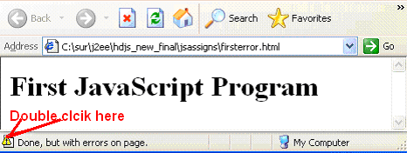

Step 5: The page is displayed with errors. To find out the error in JavaScript double-click on the icon on the status bar. A small Dialog window will display the error messages with the line number.
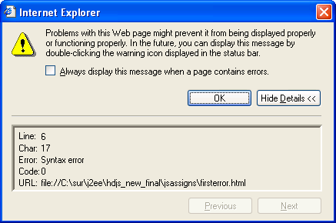

Step 6: The Dialog box is showing that the error is at line number 6 and the message is “Syntax error”. Let us examine the code at line number 6
document.write(<h1>"Displaying using JavaScript"</h1>)

We can find that the syntax is wrong. The correct syntax is
document.write(“<h1>Displaying using JavaScript</h1>”)

Step7: Correct the error and save the file as “errorfree.html”

Summary of this exercise:
You have just learnt
How to use Javascript in HTML documents.
Debug and fix the error.

Deliverables of the exercise:
- firstjs.html
- firsterror.html
- errorfree.html

Assignment 2: Using Variables and Operators.

Objective: To work with JavaScript we need to know the different types of variables and operators.

Step 1: Type the following code in an editor and save it as “varjs.html”.

<html>
<head>
<script language="JavaScript">
var num1=10;
var num2=20;
var num3=num1+num2;
document.write("The sum is "+num3);
</script>
</head>
<body>
<h3> JavaScript variable demo</h3>
</body>
</html>

Note: Variable names are case-sensitive and they must begin with a letter or the underscore character

Step 2: Modify the “varjs.html”, place the entire Javascript part inside the <body> tag and save it as “varjsbody.html”. Open the page in the browser.

Step 3: Remove the var keyword from “varjs.html” and save it as “remvar.html”. Open the page in the browser and check the output.

Note: var is used to declare a variable. In JavaScript you can use variables without declaring it. If a variable is prefixed by the keyword “var” within a function then it is a local variable, otherwise it is a global variable.

Step 4: Modify the “remvar.html”, change the variable name “num3” as “3num”. Save it as “varerror.html” Verify the output.

Step 5: Debug the error in “varerror.html” and correct it.

Step 6: Include the following code inside <head> and save it as “assign.html”.

<script language="JavaScript">
inum=55;
msg="4";
sum=msg+inum;
alert(sum); // Comment: Displays a message dialog box
</script>

Step 7: Write a program to find out 10.5 % 2.5, Save it as “mod.html”, what is the output?

Step 8: Include the following code inside <head> and save it as “unary.html”.
<script language="JavaScript">
num1 = 10; num2 = 10;
num3 = num1++;
num4 = ++num2;
</script>

Display the values of num1, num2, num3 and num4.

Step 9: Find out what is the error in the following code, save it as “varerror2.html”
<script language="JavaScript">
num1=100;
Num1+=20;
</script>

Debug the error and display the value of “num1”.

Step 9: Find out what is the value of num1 in the following code and save it as “local.html”.
<script language="JavaScript">
function fun()
{
var num1=100;
}
fun() // calling function.
document.write("the value of num1 is "+num1);
</script>

Step 9: Getting Error? Why? Debug it. (Refer the note in page-no 4)

Step 10: Modify the “local.html”, remove the “var” keyword and execute it.

Summary of this exercise:
You have just learnt
Declare and how to use variables.
Different operators in JavaScript
Difference between local and global variables.

Deliverables of the exercise:
- varjs.html
- varjsbody.html
- remvar.html
- varerror.html
- assign.html
- mod.html
- unary.html
- varerror2.html
- local.html

Assignment 3: Using Control Structures and Loops

Objective: Any logic can be created using control structures and loops. Here we are learning about the usage of control structures and loops.

Step 1: Type the following code in an editor and save it as “control1.html”

<html><body>
<h3> JavaScript Control demo</h3>
<script language="JavaScript">
/*Comments: program to find the given number is divisible by 5 and 6*/
num=30;

if((num % 5 == 0) && (num % 6 == 0))
document.write("<h3>"+num+" is divisible by both 5 & 6</h3>");
else
document.write("<h3>"+num+" is not divisible by both 5 & 6</h3>");

</script>
</body></html>

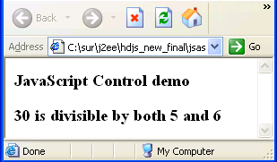

Step 2: Write a program to find the largest of three numbers using if-else control structure and save it as “control2.html”.

Step 3: Write a program to find, whether the participant has cleared the “PRP” exam or not with the following condition. To pass the exam the total mark should be greater than 65% and Sec A, Sec B, Sec C mark should be greater than 50%. Save the file as “control3.html”.

Ie, Total >= 65 /100
Sec A >= 25 / 50
Sec B >= 15 / 30
Sec C >= 10 / 20

Step 4: Find out what is the output of the following code. Save the file as “control4.html”

<script language="JavaScript">
var num=100;
var str="100";
if(num==str){
document.write("<h1> Equal</h1>");
}
else{
document.write("<h1> Not Equal</h1>");
}
</script>

Step 5: Modify the above code, replace “==” with “===”. What will be the output?

Step 6: Write a program to find whether the given character is vowel or not. Use Switch case control structure. Save the file as “switch.html”
Remember that JavaScript does not support character data type. Use String data type for doing the same. Eg letter=”A”.

Step 7: Type the following code into a text editor and save it as “for1.html”.

<html><head>
<script language="JavaScript">
/* Comments : To Display numbers from 1 to 10 using for loop in a Table format*/
document.write("<table border='1' width='30%'>");
for(i=1;i<=10;i++)
{
document.write("<tr><td>"+i+"</td></tr>");
}
document.write("</table>");
</script>
</head><body>
</body></html>

Note: When you are using attribute values inside the write method, it is better to use inside single codes. Otherwise use escape character \” like
document.write(“<table border=\"1\”>”);

Step 8: Modify the above code using while loop and save it as “while1.html”.

Step 9: Modify the above program using do-while loop and save it as “dowhile1.html”.

Step 10: Write a program to display the multiplication table of the given number using a loop. Display the output in a table format. Save the file as “multtable.html”.

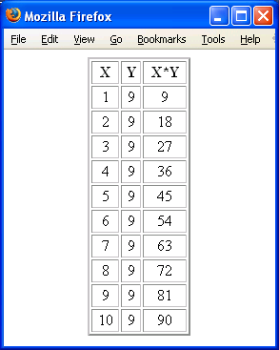
Step 11: Modify the above program and display the result inside a textbox. Save the file as “multtabtext.html”. Verify the output.
Place the <table> tag inside a <form> tag and use “text” input type. The value of the input type should be assigned dynamically.

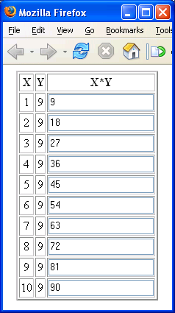

Summary of this exercise:
You have just learnt
Using control structure if-else and switch
Using for loop, while and do-while loop.
Dynamic table creation.

Deliverables of the exercise:
- control1.html
- control2.html
- control3.html
- control4.html
- switch.html
- for1.html
- while1.html
- dowhile.html
- multtable.html
- multtabtext.html

Assignment 4: Functions and Dialog Boxes

Objective: Functions are one of the fundamental building blocks in JavaScript. A function
is a JavaScript procedure—a set of statements that performs a specific task. Here we will learn how to create user defined functions and make use of in built functions.

Step 1: Type the following code in to a text editor and save it as “fun1.html”.

<script language="JavaScript">
/* Comments : function definition */
function addFun(num1,num2)
{
document.write("the sum is "+ (num1+num2));
}
/* Comments: Calling function */
addFun(10,20);
</script>

Step 2: Modify the above program,add a function for multiplying two numbers.

Note: The main advantage of a function is reusability. So instead of displaying the output inside the function return the result to the caller using the return keyword.

Step 3: Type the following code into a text editor and save it as “funreturn.html”.

<html><head>
<script language="JavaScript">
function addFun(num1,num2)
{
return num1+num2;
}
</script>
</head><body>
<h1> Function Demo</h1>
/* Comments : we can use more than one script tag in a document */
<script language="Javascript">
document.write("<h1>Sum is "+addFun(20,50)+"</h1>");
</script>
</body></html>

Step 4: Write a function called power(arg1, arg2) to find the power of the given number and save it as “power.html”.

Note: The arguments of a function are maintained in an array. Within a function, you
can address the parameters passed to it as follows: arguments[i]. The total number of arguments is indicated by arguments.length

Step 5: Type the following code and save it as “funarg.html”.

<html><head>
<script language="JavaScript">
/* Comments : function does not have any arguments, but arguments array will store the arguments */
function dispStr()
{
for(i=0;i<arguments.length;i++)
{
document.write(arguments[i]+" ");
}
}
/* Comments : Calling function with three arguments */
dispStr("1one","1two","1three");
document.write("<br>");
/* Comments : Calling function with five arguments */
dispStr("2one","2two","2three","2four","2five");
</script>
</head><body></body></html>

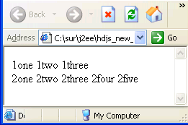

Step 6: Write a function which takes n number of arguments and return the average of n numbers and save it as “numarg.html”

Note: There are three different types of dialog boxes (alert, prompt and confirm) which are the methods of “window” object. All these three dialog boxes are modal i.e. The user must close it before continuing.

Note: Event handlers are very powerful and useful in client side scripting. They are JavaScript code that are not added inside the <script> tags, but rather, inside the html tags, that execute JavaScript when something happens, such as pressing a button, moving your mouse over a link, submitting a form ,etc. For Example
<input type="button" value="Close" name="but2" onClick="closeWin()">

Step 7: type the following code and save it as “dialog.html”.

<html><head>
<script language="JavaScript">
function dispMsg()
{
num1=parseInt(prompt("enter the first number","0"));
num2=parseInt(prompt("enter the second number"));
alert("Sum is \n"+(num1+num2));
}
function closeWin()
{
res=confirm("do you want to close the window?");
if(res==true) window.close();
}
</script>
</head><body>
<form name="f1">
<input type="button" value="Add" name="but1" onClick="dispMsg()">
<input type="button" value="Close" name="but2" onClick="closeWin()">
</form>
</body></html>

Summary of this exercise:
You have just learnt
Create and invoke user defined functions.
The arguments array and its usage
Use Dialog boxes.
Use onClik event handler.

Deliverables of the exercise:
- fun1.html
- funreturn.html
- power.html
- funarg.html
- numarg.html
- dilog.html

Assignment 5: External File and Built in Objects

Objective: To understand the usage of External JavaScript file (.js) and learn the usage of some important built in objects.

Step 1: Type the following code in to a text editor and save it as “ext.js”.
/* Comments : no need to use script tag here */
function extMsg()
{
alert("Message from ext.js");
}

Step 2: Type the following code into a text editor and save it as “ext.html”

<html><head>
<!-- Comments : Using external javascript file -->
<script language="JavaScript" src="ext.js"></script>
<!-- Comments : Normal mistake, forget to close the script tag -->
</head><body>
<input type="button" value=" Add " name="but1" onClick="extMsg()"><br>
</form>
</body></html>

Step 3: Write a program to display the current date, month and year and save it as “date1.html”. (display in a format “dd-mm-yyyy’)
Use date object and its methods.

d=new Date(); // Date object created with current date.
year=d.getYear();//getYear() returns the current year.

Step 4: Modify the above program and display the date in the following format.
“dd-mon-yyyy”.

Step 5: Write a program to generate a random number between 1 and 10. The Math.random() will generate a number between 0 and 1. Save the file as “math.html”.

Step 6: Modify the above program, display the number in words.(1 to 10). Use a switch case control structure.

Step 7: Find out what the output of the following code. Save the file as “math1.html”.
fnum = Math.ceil(-12.5111);
snum = Math.floor(-12.5111);
tnum = Math.round(-12.5111);

Step 8: Write a program to find the length of the following string and save it as “strllen.html”.
str = ”Wipro Technologies Limited”. Use the length property of the string object.
len=str.length

Step 9: Write a program to display the ASCII value of the following string. Save the file as “strascii.html”
str=”Center For Technology Excellence”.
Use the charCodeAt() function of the string object.
str.charCodeAt(0) will return the ASCII value of the first character “I”.
Use a loop for displaying the entire string.

Note: In Javascript String is an object not an array of characters, so if you want to access individual characters you need to use the methods associated with the string object.

Step 10: Write a program to find the occurrence of “@” and “.” in the following email address. Make sure that there is only one occurrence of “@” character. Save the file as “email.html”
email=”MeetAt@Wipro.com”
Use the following String methods
- indexOf(searchValue[, fromIndex])
- lastIndexOf(searchValue[, fromIndex])

Eg. Here num= email.indexOf(“@”) , the num value is “4”.

Step 11: Write the program to find the length of the following Array. Save the file as “array.html”.
var arr =new Array(1,2,55,66,33,22,1);
Use the length property of the Arary.
Step 12: Modify the above program and display individual elements.

Step 13: Modify the above program and reverse the “Array”. Use the reverse() method of the Array object. Save the file as “arrayrev.html”.

Step 14: Modify the above program and find the biggest and smallest elements in the Array and save it as “bigsmall.html”.

Step 15: Divide the following sentence into words and display in the ascending order of words. Save the file as “split.html”.
sent=”javascript is very easy to learn”.
You can use the split() method of the String object to split the sentence to an Array of Strings.
wordarr=sent.split(“ “);// splitting on each space.
wordarr is become an array of string.
Use the sort() method of the array for sorting the string

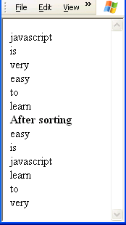

Summary of this exercise:
You have just learnt
Using external Javascript file
Working with Date, Math, String and Array Object.

Deliverables of the exercise:
- ext.js
- ext.html
- date.html
- math.html
- math1.html
- strlen.html
- strascii.html
- email.html
- array.html
- bigsmall.html
- split.html

Assignment 6:Working with DOM and Important objects

Objective: DOM defines the document object hierarchy, here we are learning about the usage of different objects and its usage.

Step 1: Type the following code and save it as “navigator.html”.
<script language="JavaScript">
document.write("the browser name is "+navigator.appName);
</script>

Note: “navigator” object contains information about the browser and it’s version.

Step 2: Modify the above program and find the operating system and version of the browser.
Use the appVersion and platform properties of the navigator object.

Step 3: Type the following code and save it as “newwin.html”.
<html>
<head><title> New Window</title><head>
</body>
<font color="red" size="5"> New Window</font>
</body>
</html>

Step 3: Type the following code and save it as “mainwin.html”.

<html>
<head><title> Main Window</title>
<script language="JavaScript">
function openNew(){
newwin=window.open("newwin.html","newone");
}
</script>
</head><body>
<font color="red" size="5"> Main Window</font>
<input type="button" value=" Open " onClick="openNew()">
</body></html>

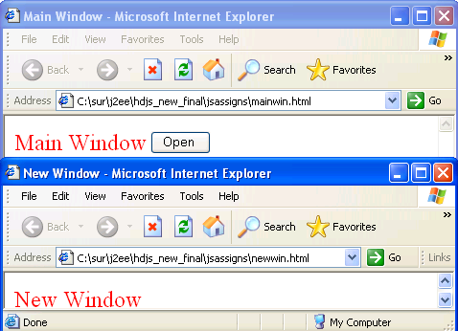
Note: Consider newwin=window.open("newwin.html","newone"), “newwin” is the object reference to the new window, “newwin.html” is the html file you want to open and “newone” is the name of the new window.

Step 4: Modify the above program, replace the function with the following code.

function openNew(){
newwin=window.open("newwin.html","newone","width=300;
height=400;toolbar=no");
}

Step 5: Save the “mainwin.html” as “mainclose.html”. And modify the following
Insert button with a value “close” and onClick of the button call the following function.
function closeWin()
{
/* Comments: newwin is the reference of the new window */
newwin.close();
}

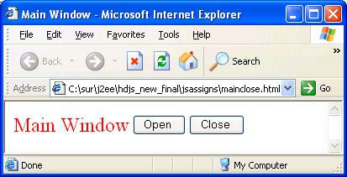

Step 6: Type the following code and save it as “status.html”

<script language="JavaScript">
/*Comments: set a string in the browser status bar */
window.status="Check the status bar";
//status="Check the status bar";
</script>

Note : If the status bar is not visible, select menu option, view->status bar.

Step 7: Type the following code and save it as “history.html”.

<html><body>
<h1>History demo</h1>
<!-- Commnets : Using Inline JavaScript -->
<input type="button" value="back" onClick="history.go(-1)">
</body></html>

Note : If you want work with history object more than one page should be loaded in to the browser.

  - Open “status.html”
  - In the same browser open “history.html”

Step 7: Type the following code and save it as “location.html”.

<html><head>
<script language="JavaScript">
function fun() {
location.href="status.html";
}
</script>
</head><body>
<h3> Location Demo</h3>
<input type="button" value="change" onClick="fun()">
</body></html>

Step 8: Modify the above program, use location.replace(URL) method for replacing the page. Display the hostname and protocol. (Use protocol and hostname properties)

Step 9: Type the following code and save it as “doc.html”

<body>
<h3> BGCOLOR Demo</h3>
<input type="button" value="change"
nClick="document.bgColor='cyan';">
</body>

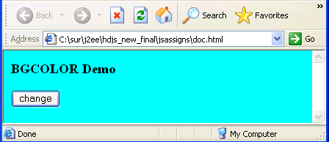

Step 9: Modify the above program, add one more button to change the foreground color of the document. (Use fgColor property of document object). Save the file as “fgcolor.html”

Step 10: Write a program to open another document, when the user clicks on the change button. Save the file as “url.html”.
Use URL property of the document object.

Step 11: Write a program to display the last modified date of the HTML document. Save the file as “lastmod.html”. ( use lastModified property of document object).

Summary of this exercise:
You have just learnt
How to use the following objects.
navigator
window
document
history
location

Deliverables of the exercise:
- navigator.html
- newwin.html
- mainwin.html
- mainclose.html
- status.html
- history.html
- location.html
- doc.html
- fgcolor.html
- url.html

Assignment 7: Working with Form and Elements

Objective: One of the Web’s most interesting possibilities is the creation of interactive features. You can interact to the website using form elements. Here we are going to learn about how to access the form elements.

Note: In “DOM” you can access each element in a form using the following hierarchy.
window -> document -> form -> element

Step 1: Type the following code and save it as “actionpage.html”.

<html><body>
<h3> Action page demo</h3>
</body></html>

Step 2: Type the following code and save it as “mainform.html”. Open the page in a browser, click on the submit button verify the URL.

<html>
<body>
<h1> Form Demo</h1>
<form name="frm1" action="actionpage.html" method="get">
<input type="text" name="txt1" value="Wipro"><br>
<input type="submit" value="submit">
</form></body>
</html>

Step 3: Modify the above program, set the method attribute value as “post”. Open the page in a browser, click on the submit button verify the URL.
<form name="frm1" action="actionpage.html" method="post">

Step 4: Modify the above program, change the “submit” to “button” and save the file as ”mainform1.html”. Click on the button. What is the Output?
<input type="button" value="submit">

Note: Button can not submit the form to the server unless and until you incorporate client side scripting. Use the submit method of the form for doing the same.

Modify the above program using the following code.
<input type="button" value="Submit"
onClick="document.frm1.submit()">

Note: Submission of the form is required only for the server side programs. We are dealing with client side programs. So at the point of time we are not dealing with the submission of the form.

Step 5: Type the following code and save it as “formelement.html”

<html><head>
<script language="JavaScript">
/*Comments: only three elements in the form, to access that we can use elemenmts array */
function funDisp()
{
alert("textbox val is "+document.forms[0].elements[0].value);
alert("textbox val is "+document.forms[0].elements[1].value);
alert("textbox val is "+document.forms[0].elements[2].value);
}
</script></head><body>
<form name="frm1">
<input type="text" name="txt1" value="Wipro"><br>
<input type="radio" name="rad1" value="1" checked>Ok<br>
<input type="button" value="Submit" name="but1" onClick="funDisp()">
</form></body></html>

Step 5: Modify the above program, replace the function with the following function. Save
the file as “formnames.html”.

/* If we know the name of the form and elements, we can use it directly, “frm1” is the name of the form and “txt1” is the name of the textbox */
function funDisp()
{
alert("textbox val is "+document.frm1.txt1.value);
alert("textbox val is "+document.frm1.rad1.value);
alert("textbox val is "+document.frm1.but1.value);
}

Step 6: What about accepting input from the user. Type the following code and save it as “addnum.html”. Enter two numbers and click on the Add button.

<html><head>
<script language="JavaScript">
function addNum()
{
num1=document.frmadd.txt1.value;
num2=document.frmadd.txt2.value;
num3=num1+num2;
document.frmadd.txt3.value=num3;
}

</script></head><body>
<form name="frmadd">
Num1 <input type="text" name="txt1"><br>
Num2 <input type="text" name="txt2"><br>
Result <input type="text" name="txt3" disabled><br>
<input type="button" value="Add" name="but1" onClick="addNum()">
</form></body></html>

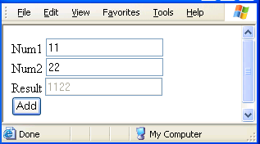

Step 6: The sum of “11” and “22” is giving as “1122”. Who is responsible for this mistake? Yes it is our mistake, here two strings are getting concatenated and the result is a string. So before adding the numbers convert them to a number.

Note: Any value from a form element will treat as a String, so before doing mathematical calculation convert them to numbers.

Modify the above program using the following modification.

function addNum()
{
num1=parseInt(document.frmadd.txt1.value);
num2=parseInt(document.frmadd.txt2.value);
num3=num1+num2;
document.frmadd.txt3.value=num3;
}

Step 7: Save the above file as “simplecalc.html”. Add three more buttons and functionality for subtracting, multiplying and dividing two numbers.

Step 8: If the user enters only numbers it works fine, but if the user enters a string then the result will be “NaN”. How can we avoid this. Why can’t we check the validity for the data entered by the user. i.e check if the input is correct or not.
We can use the Top Level function “isFinite()” and “isNaN()”for checking if the given string is a number or not.

Consider the following code for checking the first textbox value is a number or not.

/*Comments : Not isFinite() will return true if num1 is a string */

if(!isFinite(num1))
{
alert("Please eneter a number!");
return false;
}

Modify the “simplecalc.html” save as “simplecalcval.html”.

Step 9: Create a form with a username filed and a password field (A textbox and password type) and save it as “user.html”. Make sure that user is entering a minimum 8 characters and a maximum of 15 characters.

Use maxlength=15 attribute of <input> for checking the maximum length.

Step 10: Display a multiple choice question with four choices (Use a radio group with the name “rad”). When the user chooses the answer and click on the button it should display the answer is correct or not. Save the file as “apti.html”.

All radio buttons should have the same name(“rad”), so use array of objects and access individual elements using rad[0], rad[1], rad[2], and rad[3]. Use the “checked” property of the radio button to check the user is selected the radio or not.

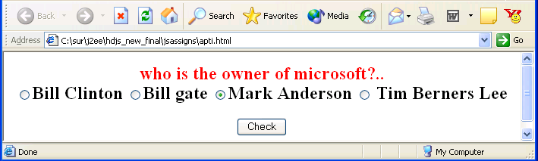

Step 11: Type the following code and save it as “select.html”.

<html><head>
<script language="JavaScript">
function disp()
{
ind = document.f1.webs.selectedIndex;
//Comments : index of the selected Item
alert("the value is \n"+document.f1.webs.options[ind].value);
alert("the text is \n"+document.f1.webs.options[ind].text);
}
</script>
</head><body>
<form name="f1">
<select name="webs" onchange="disp()">
<option value="1"> http://sparsh
<option value="2"> http://kshop
<option value="3"> http://172.21.20.155/
<option value="4">http://newmywipro.wipro.com/
</select>
</form></body></html>

Step 12: Save the above program as “selectwebs.html”. When the user selects a particular website it should redirect to the particular site.

Step 13: Create a textarea for accepting feedback from the user, do not allow the user to enter more than 200 characters. Save the file as “textarea.html”.

Step 14: Write a program to display a stop watch. When user clicks on the start button it should start display the number of seconds and when user clicks on the stop button it should stop counting.

Use id = setTimeout(funName, time in MS) method of window object for calling a function recursively with a time delay. Use clearTimeout(id) for stop the function call. Save the file as “stopwatch.html”

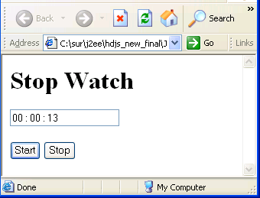

Step 15: Create the following form, do the validations. Save the file as “val.html”.

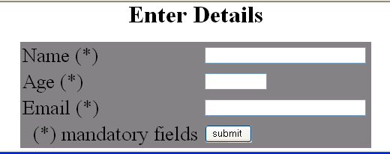

  - All the fields are mandatory.
  - Name should be a sting with minimum 3 Character.
  - Age should be a number between 1 and 100.
  - Email should be a string with and “@” and “.” Character.

Summary of this exercise:
You have just learnt
Working with form and its properties.
Working with the following form elements
Text
Password
Textarea
Radio
Select
Form Validation

Deliverables of the exercise:
- actionpage.html
- mainform.html
- mainform1.html
- formelement.html
- formnames.html
- addnum.html
- simplecalc.html
- simplecalcval.html
- user.html
- apti.html
- select.html
- selectwebs.html
- textarea.html
- stopwatch.html
- val.html.

